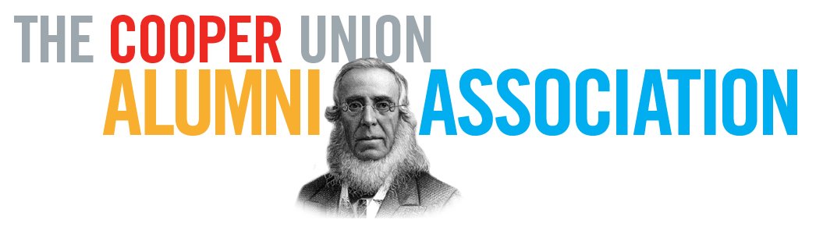

The Cooper Union Alumni Association
2016 Founders Day Alumni Award Nomination Form

Instructions: Please fill out the fields below and save the file in the following format with the nominee’s last name in the file name; i.e.: CUAA_LASTNAME.docx. Please email the saved completed form and supporting documents to contact@cooperalumni.org with the subject line: “Alumni Award Nomination for Art/Arch/Eng/Public”. Deadline to submit a nomination is November 30, 2015. Additional instructions can be found here.

Select Award: Augustus St. Gaudens Award for Art
Gano Dunn Award for Engineering
John Hejduk Award for Architecture
Peter Cooper Public Service Award

Name of the person you are nominating:
Nominee’s Year of Graduation:
Nominee’s Major:
Nominee’s Email:
Nominee’s Phone/Cell Number:
Nominee’s Website:
(if applicable)
Nominee’s Work address:
Nominee’s Current Occupation:
Explain why you are nominating this candidate:
Candidate's Career Highlights:
(You are encouraged to attach supporting documents)
Candidate’s Outstanding Accomplishments and Awards: (You are encouraged to attach supporting documents)
Describe Candidate’s work in Public Service, if applicable:
(You are encouraged to attach supporting documents)

Your Name:
Your Relationship to Nominee:
Your E-mail:
Names of Alumni (along with email addresses) who support this nomination: (optional)

